ORDER PRECEDENCE:
Brackets
Not
Xor
And
Or
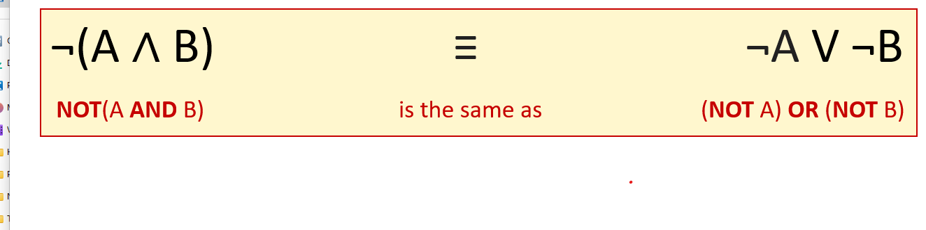
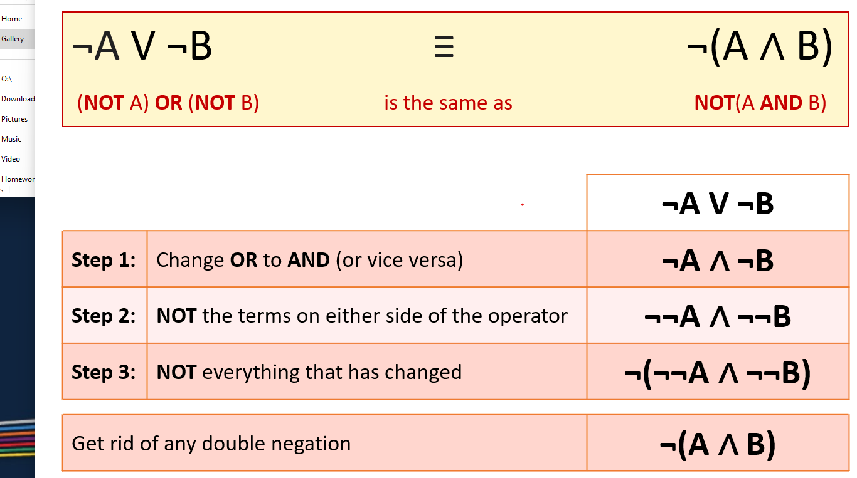
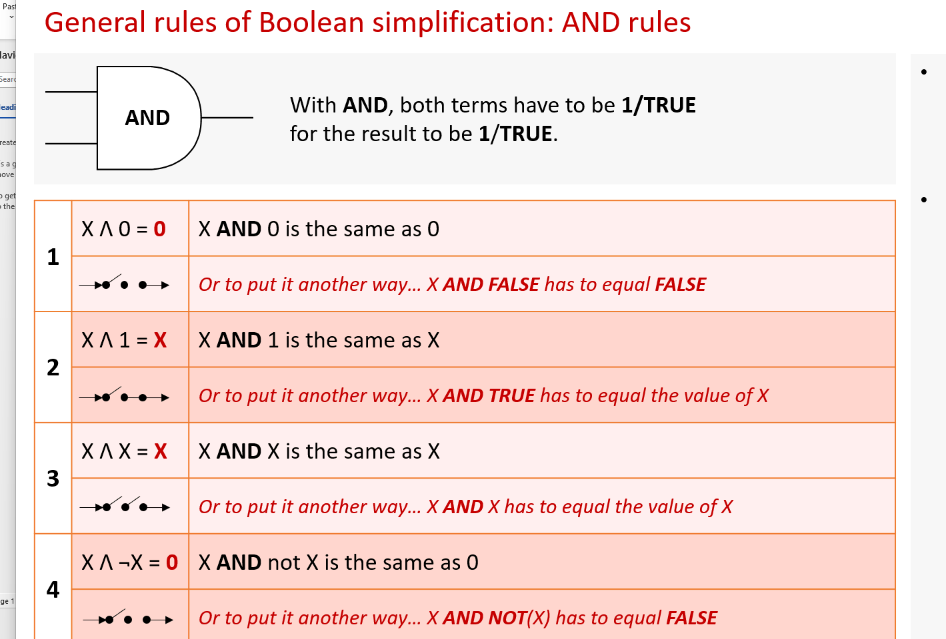
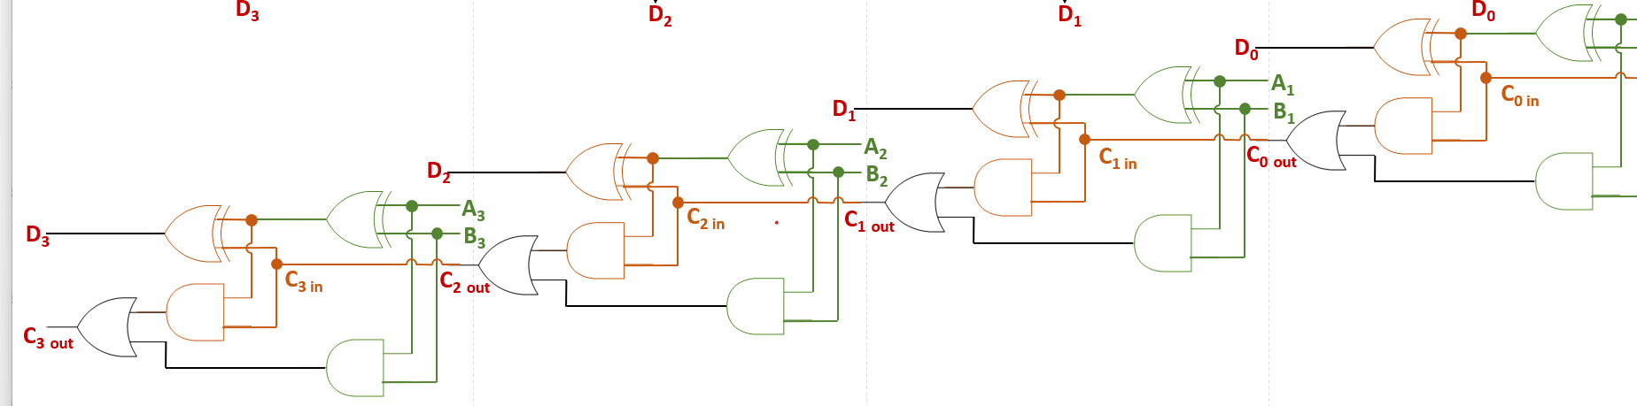
2026
Purpose of a flip flop: Store the state of a bit
De morgans law: Not(A and B) = Not A or Not B
Association: (A and B) and c = A and (B and C)
Commutativity: A and B = B and A
Distribution: A and (B or C) = (A and B) or (A and C)
Absorption: A and (A or B ) = A A or (A and B) = A

